ShopEasy QA – Test Management Summary Report

1. Project Overview
Project: ShopEasy QA
Project Key: SEQ
Platform: Jira Cloud
Test Management Tool: Xray
Environment: Build 1.0.3, Staging, Latest Chrome, Windows 11
The objective of this project was to perform requirement-based testing of the ShopEasy e-commerce application. The testing covered user account management, product catalogue, shopping cart, and checkout functionality.
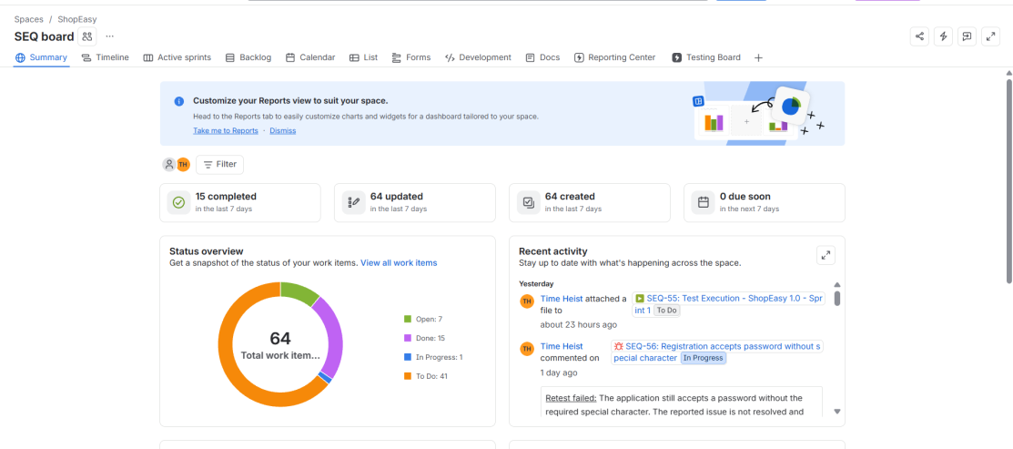
Jira Project Link: Link to Space
Project Key: SEQ
Dashboard: ShopEasy QA Dashboard
Test Execution: SEQ-55

2. Project Scope
The project contains:
- 3 Epics covering the major application modules.
- 15 User Stories linked to the Epics.
- 2 completed Scrum sprints.
- 35 Xray test cases linked to their respective stories.
- 1 Test Plan and 1 Test Execution.
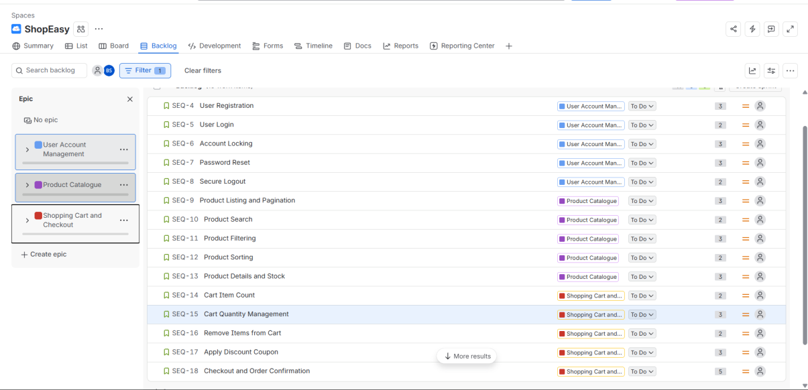
Testing included positive, negative, and boundary scenarios.
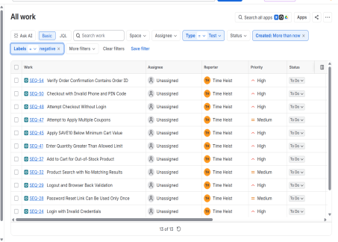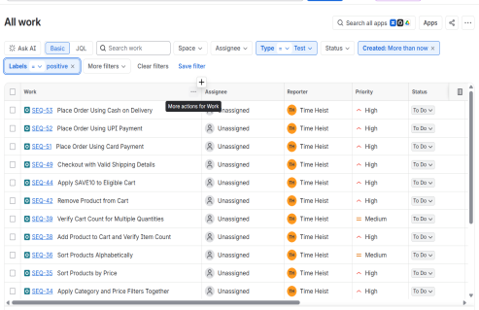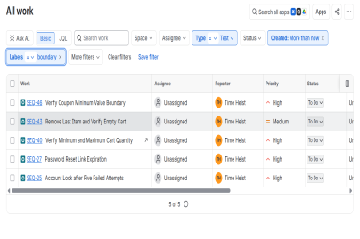

3. Test Execution Summary
Execution Status | Number of Tests
Total Tests | 35
Passed | 27
Failed | 8
Blocked | 0
Not Run | 0

Pass Percentage: 77.14%
Fail Percentage: 22.86%
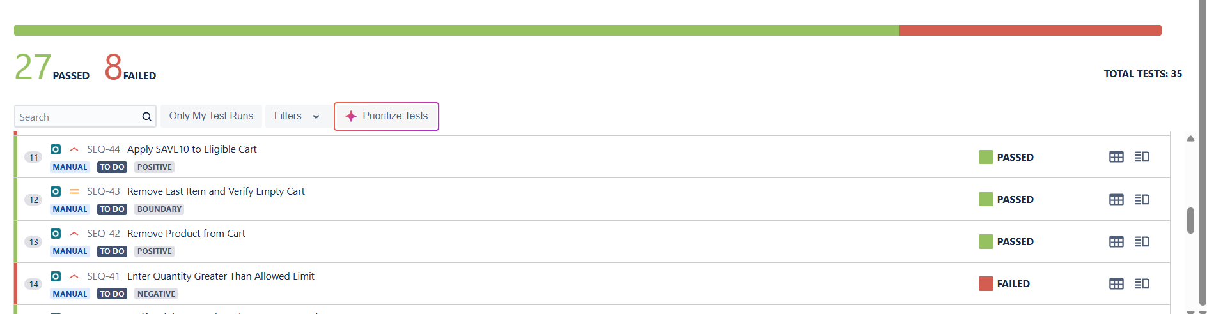

4. Defect Summary
A total of 8 defects were identified based on the supplied application observations.
The defects cover:
- Registration password validation.
- Account lock duration.
- Password reset link expiration.
- Case-insensitive product search.
- Product sorting.
- Cart quantity validation.
- Discount coupon eligibility.
- Order confirmation ID display.
All 8 defects were documented with their requirement IDs, reproduction steps, expected results, actual results, priorities, and related test cases and stories.
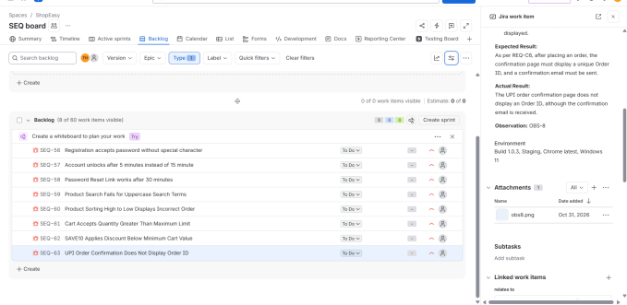

5. Defect Lifecycle
A dedicated Bug workflow was configured:
Open → In Progress → Fixed → Retest → Closed
One defect was moved through the workflow to demonstrate a failed retest and returned to In Progress with an explanatory comment.
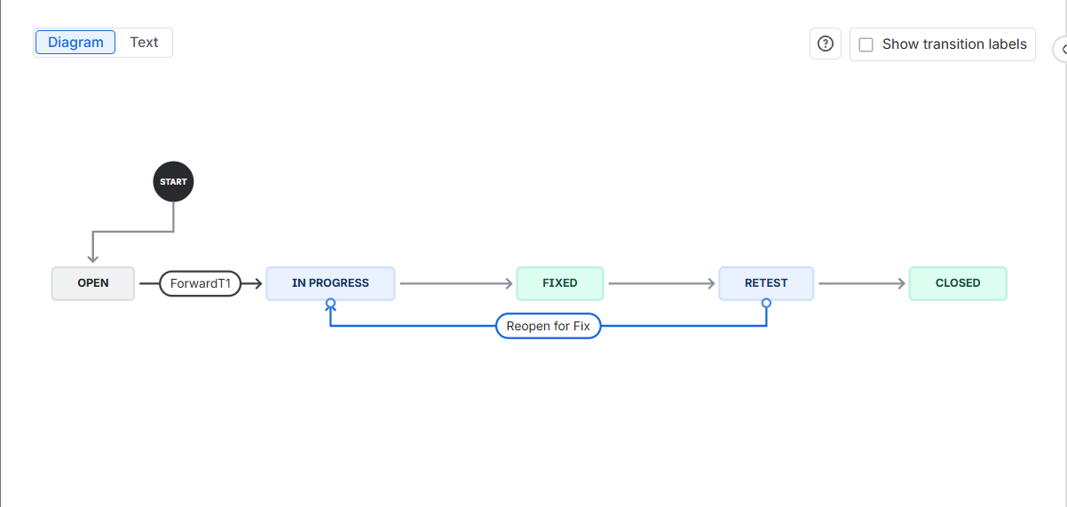

6. Dashboard and Filters
A dashboard named ShopEasy QA Dashboard was created with gadgets for sprint progress, defect analysis, created versus resolved work items, and filtered work-item results.
Five JQL filters were saved:
- All Open Bugs
- Open High Priority Bugs
- Bugs by Assignee
- Failed Tests
- Stories in Sprint 1
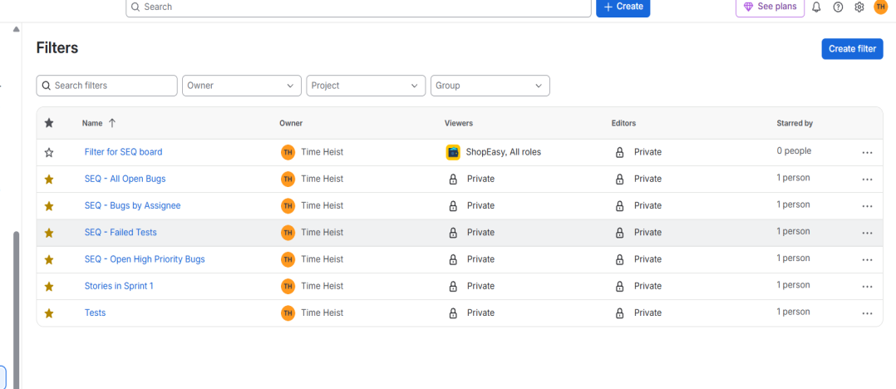

7. Testing Metrics
- Pass Rate = Passed Tests / Executed Tests × 100
- Fail Rate = Failed Tests / Executed Tests × 100
- Defect Density = Total Defects / Number of Stories
- Requirement Coverage = Requirements Tested / Total Requirements × 100
- Defect Closure Rate = Closed Defects / Total Defects × 100

8. Conclusion and Recommendation
The testing exercise identified 8 defects across important application functionalities. Although 27 tests passed, the 8 failed tests indicate that some requirements are not yet satisfied.
Recommendation: NO-GO for release until the identified defects are fixed and successfully retested.

